

Republic of the Philippines
PALOMPON INSTITUTE OF TECHNOLOGY
Palompon, Leyte
COLLEGE OF TECHNOLOGY AND ENGINEERING
INFORMATION TECHNOLOGY DEPARTMENT
IT 118: Software Engineering
DESIGN AND DEVELOPMENT OF A WEB – BASED RESERVATION AND SCHEDULING SYSTEM FOR SCHOOL VENUES AND EQUIPMENT AT PALOMPON INSTITUTE OF TECHNOLOGY, PALOMPON LEYTE
Submitted as a Partial Requirement for this Course by:
"Campus Tech Solutions”
BSIT 3 - B
Andales, Nick Vincent D.
Barro, Daniel Zrael C.
Betoy, Ephraim D.
Dangel, Jenevieve A.
Nuñez, Ana May M.
Submitted to:
Rogelio G. Urboda Jr.
Subject Instructor

March 24, 2026

NON-FUNCTIONAL REQUIREMENTS

1. Usability
1.1 The system shall provide a user-friendly interface that allows students, faculty, and staff to easily navigate the platform.
1.2 The system shall provide clear instructions and labels for submitting reservation requests.
1.3 The system shall be accessible through standard web browsers on desktops, laptops, and mobile devices.
1.4 The system shall present information such as schedules and request status in a readable and understandable format.

2. Performance
2.1 The system shall support multiple users accessing the system simultaneously without significant delays.
2.2 The system shall update reservation schedules and availability in near real-time.
2.3 The system shall load pages and system interfaces within an acceptable response time under normal internet conditions.
  - The system shall maintain stable performance when multiple authorized users access the system simultaneously.

3. Security
3.1 The system shall implement role-based access control (RBAC) to restrict access according to user roles.
3.2 The system shall protect stored data from unauthorized access.
3.3 The system shall automatically log out users after 15 minutes of inactivity to prevent unauthorized access to user accounts.

4. Reliability
4.1 The system shall maintain consistent operation during normal usage.
4.2 The system shall ensure that reservation data is accurately stored and retrieved from the database.
4.3 The system shall minimize data loss through proper database management.

5. Availability
5.1 The system shall be available to users anytime with an active internet connection.
5.2 The system shall allow users to check venue and equipment availability in real time.

6. Maintainability
6.1 The system shall allow administrators to update venues, equipment lists, and schedules easily.
6.2 The system shall be designed so that future updates or improvements can be implemented efficiently.

7. Scalability
7.1 The system shall be capable of handling additional venues, equipment, and users if the institution expands the system in the future.

8. Real-time Communication
8.1 The system shall utilize Web Socket technology to enable real-time communication between the client and server, allowing instant updates of reservation status, schedules, and notifications without requiring page reloads.
8.2 The system shall ensure that Web Socket implementation is compatible with chromium-based and modern web browsers (e.g., Chrome, Edge, Firefox, Safari) to maintain consistent real-time functionality across user devices.
8.3 The system shall ensure low-latency data transmission to provide faster response times compared to traditional HTTP request-response communication.
8.4 The system shall support bidirectional communication between client and server to allow simultaneous data exchange.

ENTITY RELATIONSHIP DIAGRAM (ERD)
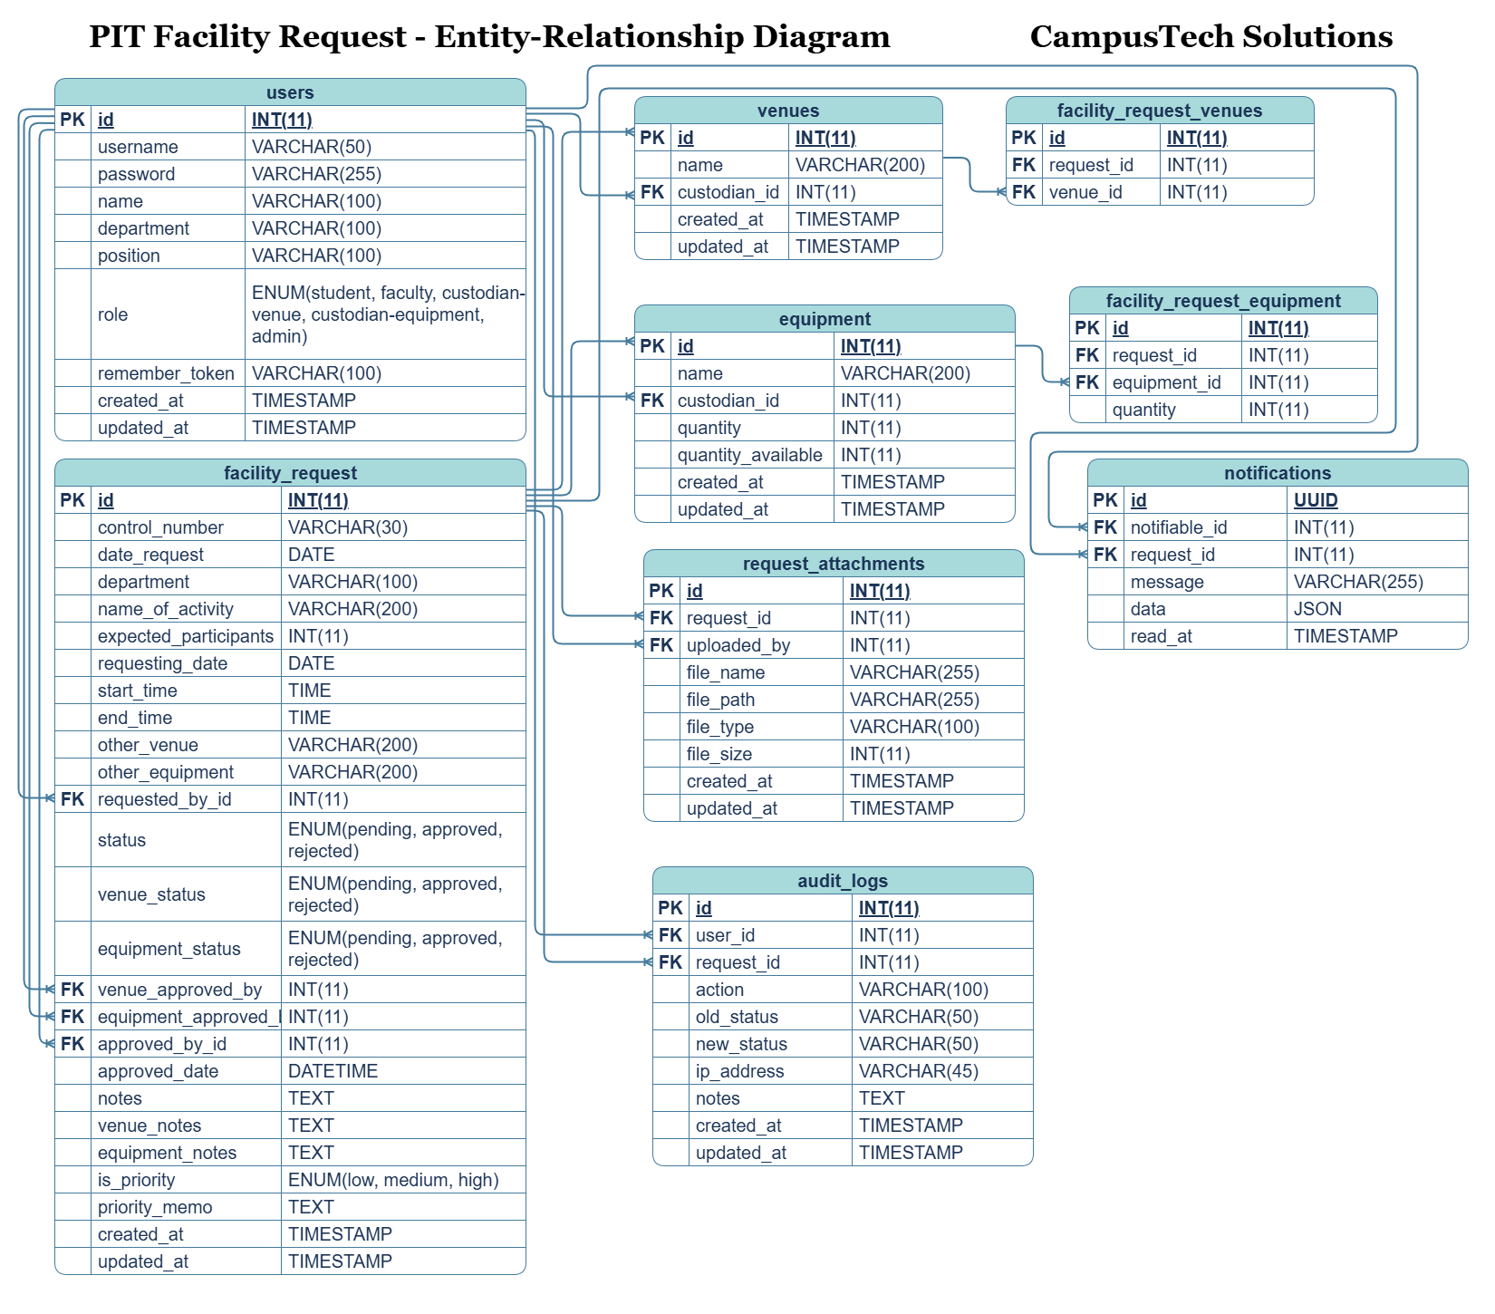

FUNCTIONAL REQUIREMENTS

1. User Account Management
Guest
- Access the system without logging in
- View limited system information (e.g., available venues and schedules)
Requester (Students, Faculty, Staff)
- Register an account to access the system
- Log in and log out securely
- Update personal account information
Custodian
- Log in and log out securely
- View assigned reservation requests
Supply Office Administrator
- Log in and log out securely
- Create, update, and deactivate user accounts
- Assign roles to users
- Manage user status (active/inactive)

2. Reservation Request Management
Guest
- View reservation guidelines and policies (if applicable)
Requester
- Create reservation requests for school venues and equipment
- Select available date, time, and venue
- Specify quantity of required equipment
- View and track the status of submitted reservation requests
Custodian
- View reservation requests assigned to them

Supply Office Administrator
- View all reservation requests
3. Scheduling and Availability Management
Guest
- View available venues, equipment, and schedules in real time
Requester
- View real-time availability of venues and equipment
Custodian
- View schedules of assigned venues
Supply Office Administrator
- Monitor all schedules
- Ensure that scheduling conflicts are prevented

4. Approval Management
Custodian
- Review reservation requests
- Approve or reject reservation requests for initial endorsement
Supply Office Administrator
- Review endorsed reservation requests
- Approve or reject reservation requests for final decision

5. Notification System
Requester
- Receive notifications regarding request status (approved or rejected)
Custodian
- Receive notifications for new reservation requests
Supply Office Administrator
- Receive notifications for endorsed reservation requests

6. Resource Management
Supply Office Administrator
- Add, update, and delete venues
- Add, update, and manage equipment inventory
- Monitor resource availability
7. Reporting and Monitoring
Supply Office Administrator
- Generate reports on facility and equipment usage
- View reservation history and records
- Access reservation logs for tracking and auditing

